UNDERTAKING A RISK ASSESSMENT FOR MANAGING SCHOOLS DURING COVID 19 OUTBREAK
With the restrictions easing, consideration must be given to the safe return to work for staff members and pupils. This involves carrying out a risk assessment for managing your place of work during the Covid 19 outbreak.

The following guidance will help you prepare a risk assessment on SPHERA (health and safety management system). It includes columns identifying ‘Hazards’; ‘Control measures’ and visual examples.

Please note that the content below is not exhaustive and will need to be amended and revised, as required, by the oversight team (C Biddick, D Burgess, H Lyon R Jamieson, D Razavi, R Merson, R Astor, P Beards) and in discussion with staff.

Reviewed and updated 13/8/20 (DB,PB,RM,RA)
Updated 11/09/20 (HL,PB)
Updated 2/11/20 (HL)
Updated 12/11/20 (HL)
Updated 22/1/21
Updated 15/3/21 (HL)

Hazards |  | Control measures | Examples
Working with members of staff in the school. |  | Every member of staff will be fully briefed to ensure that that they are aware of the hazards and risks and understand the rules and procedures put in place.  If staff have a new, continuous cough, high temperature, loss of taste / smell, they will be informed to stay at home, self-isolate and call / email their line manager. They will be advised to consult: www.nhsinform.scot, if they cannot access the advice online, they would call 111.  If advised, staff will follow the requirements of ‘Test and Protect (Test, Trace, Isolate and Support)’.  If symptoms start to develop over the working day, staff will be sent home immediately and told to self-isolate. Their work area will be isolated and sign displayed to prevent anyone using it, until there has been a special clean and where necessary, the business contingency plan implemented.  All staff will maintain social distancing within the school of two metres at all times.  Cleaning / janitorial staff will regularly clean the door handles, sink taps within the building. Teaching / assistant staff will maintain good hygiene standards, (use sanitiser provided), and wipe over surfaces where required, e.g. shared equipment, kettles, fridge, etc.  Staff will be encouraged to:  - Speak up / report - “Say if it’s Not Okay”.  - Prepare food at home and so that they can avoid the need to visit takeaways / shops at lunch breaks and the potential exposure to infection.  - If they wish, to wear a face covering / face mask during school hours. | Staff briefing on return and revised risk assessment.  Purchase sanitiser – 60 bottles for rooms  Handwashing facilities – ensure adequate paper towels/soap in relevant areas  Gloves/Masks/Visors available for all staff.  Cover to be factored in.  Isolation room in Guidance corridor and 2nd room being identified.  Schools Group Manager contact for cleaning.  SMT, Union reps and PT’s are all contacts for “Say if it’s not ok”. Staff to be actively encouraged to discuss concerns and be involved in creating solutions.  If multiple staff have to be sent home ill the HT will discuss cover arrangements with the Schools Group manager.  Revised discipline expectations to be shared by C Biddick.  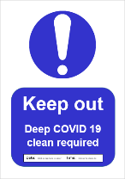
Pupil displaying symptoms. |  | If pupils are found on arrival, or if signs of continuous coughing, high temperature, loss of taste / smell develop during the working day they will be placed in isolation and their parents / guardian will be called to collect them. If there are any immediate concerns an ambulance would be called.  The area where the pupil was working will be isolated and sign displayed to prevent anyone using it, until there has been a special clean and where necessary, the business contingency plan implemented.  If advised, will follow the requirements of ‘Test and Protect (Test, Trace, Isolate and Support)’.  Cleaning / janitorial staff will regularly clean the door handles, sink taps within the building. Teaching / assistant staff will maintain good hygiene standards, (use sanitiser provided), and wipe over surfaces where required, e.g. shared equipment, kettles, fridge, etc.  The rule of social distancing will be maintained at all times, i.e. 2 metres between all staff within the building and between staff and students. If there are any issues, appropriate enforcement/ isolation will be required. The posters showing 20 second hand washing guidance / Covid 19 safety guidance will be displayed throughout the school hub area.  Pupil may wear if they wish their own face covering / face mask during school hours, (not supplied). | Medical room/Isolation room (Guidance Corridor) – Cleaning during the day if used. Alternate room available.  Capacity required to decant classes if necessary due to illness during the day.  Posters etc supplied from centre.  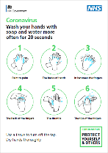
Hazards | Control measures |  | Examples
Maintaining social distancing within the school | All staff will aim to maintain social distancing of two metres at all times for everyone within the school, (for social distancing to work while Midlothian Council can set up social distancing measures to promote this, but there is an individual responsibility by every staff member to make it work), this will include:  - 2m distancing boxes to be marked around teacher desks.  - A reduction in pupils numbers entering or exiting the building at any one time.  - Utilising breakout spaces, dining space, libraries and indoor sports spaces as lunch wet weather spaces.  To aid in the management of pupils with ASN support needs with social distancing, they will be:  - Designated pod support rooms  - Subject specific software added to relevant computers to allow for extracted support with social distancing.  To minimise the need for large numbers of pupil transits and manage social distancing within the school:  - Agreed staggering of start / finish times for S1-3 and S4-6  - Stairways to be designated “up” or “down”. Movement to be monitored and plans amended as required.  - Students should not line up outside classes and should enter on arrival and go straight to their desk.  - Two metre distancing points will be marked on the floor, (in front of photocopier, printer; water fountains, staff kitchen areas) and social distancing posters will be displayed at the entrance and throughout the school. |  | Information on school operation, behaviour and discipline and health procedures sent to parents.  Staggered start times for S1-3 and S4-5  SFL “Pod” Support rooms  School plans with entrance/exit designations and stir flow to be created.  Explanatory Powerpoint for Students on start in August.  Tape being provided by Midlothian Council  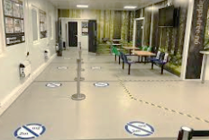  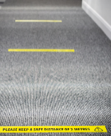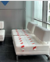  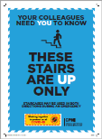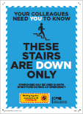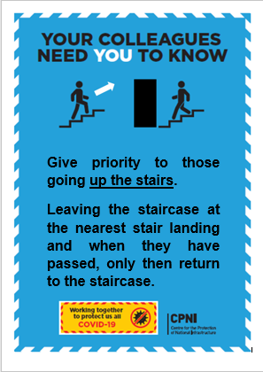  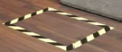
Hazards | Control measures |  | Examples
Maintaining social distancing within the school (continued) | - All lifts in the school will have metre standing distancing point will be marked on the floor next to the lift and a signage displayed stating 1 person only in the lift.  - School staff and pupils will be provided with a school plan detailing entry / exit points and new circulation patterns. Plans will also be displayed on notice boards. To manage social distancing in learning accommodation:  - All non-essential items in the learning accommodation will be removed into storage to maximise capacity and decrease the number of items requiring cleaning.  - There will be no pupil ‘hot desking’, pupils will sit at their designated desk and when the lesson / class starts and finishes, pupils will wipe clean the desk surface and chair with the sanitising material supplied.  - Learning accommodation will be demarcated in to individual pupil work areas to ensure social distancing will be maintained and no face to face working, this includes:  - Repositioning furniture  - To manage social distancing in the breaks / dining area / toilets:  - Pupil groups will be kept separate at break times and when they are given lunch, with each being given their own area to use.  - Pupils will be informed that they must maintain physical distancing as much as possible with signage displayed throughout the school. Younger pupils, to stay in their small / designated groups during social times, with appropriate supervision to facilitate this.  - Pupils will be encouraged to remain onsite for lunch wherever possible, to minimise unnecessary interactions with others off the school premises.  - Signage to be displayed on the outer toilet block wall stating that a designated number can be in the toilet block at any one time.  - To manage social distancing in the staff room / kitchen area:  - Signage will be displayed on the door stating how many can be in the room.  - All non-essential items will be removed into storage to maximise capacity and decrease the number of items requiring cleaning and tables / chairs will be repositioning taped over / removing into storage. |  | Tape source and will be placed subject to government guidelines  School plans and entry/exit information being created.  Explanatory Powerpoint for Student on start in August  Sanitising wipes required for classes.  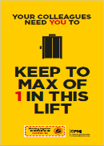  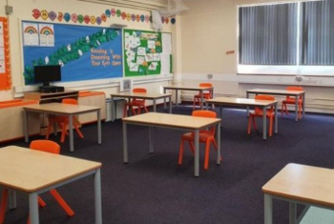  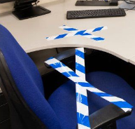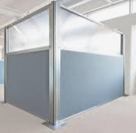  Reduced lunchtime/packed lunched required or available from bitesite. Ordering system to be established  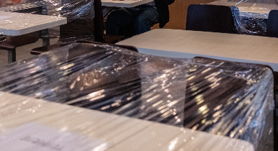  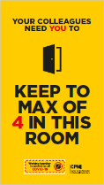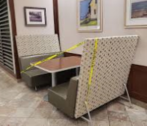  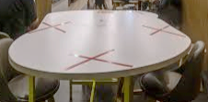

Hazards | Control measures | Examples
Maintaining social distancing within the school (continued) | - Social distancing will be maintained in the staff kitchen area.  (In enclosed small kitchens, if the risk deemed too high, consideration will need as to whether to close off and inform staff that they will need to bring their own drinking water, kettle, cups or instruct staff to knock on the door before entering. Signage will be displayed on the door stating how many can be in the kitchen).  (In open plan kitchens two metre demarcation areas will be marked on the floor, in larger kitchen area there may be more than one demarcated area).  - To manage social distancing at the drop off and pick up point:  - A sign will be displayed on the main door providing guidance.  (Parents / carers of pupils with complex needs or disabilities, who may normally drop their children off within the school building will need informing of the arrangements for accessing the school).  - Two ensure there is no overcrowding parents / guardians will be advised that only one parent / guardian will be allowed to drop off and collect each child, with no gathering by the school gates  - To aid in the management of pupil social distancing during arrival and departure:  - Staggered drop off / pick up times, so that not all pupils arrive / leave at one time.  - On arrival, pupils will head immediately on to their small group’s designated learning area, i.e. circulation space / classroom. For those arriving by car, parents / carers will be informed of the temporary measures in place including:  - No drop off area near the school, they will need to park further away from the school and then walk with their children to avoid congestion,  - Car-sharing with children of other households should be discouraged.  Should there be a requirement for face-to-face working for a sustained period a specific risk assessment will be undertaken to see whether the activity can safely go ahead. No one within the school is obliged to work in an unsafe environment. | 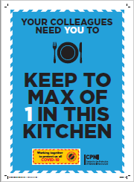  Parental Information Letter to be sent outlining requirements.  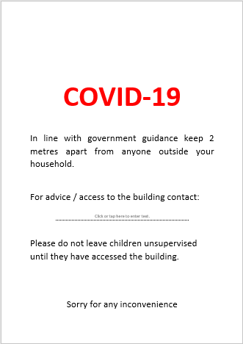

Hazards | Control measures | Examples
Touching desks, cabinets, equipment, and fixtures / fittings, e.g. door handles, taps. | Cleaning / janitorial staff will provide enhanced cleaning, with regularly cleaning of the door handles, light switches, doorframes, taps and toilets within the school. Teaching aids and books used by children would be wiped clean between use, by the relevant staff / pupils with the sanitising material supplied.  The water fountain should have a sanitisation station next to it.  Lid should be removed from all waste bins.  Should there be a incident where a member of staff / pupil show signs of COVID 19 and are sent home, their work area will be isolated and sign displayed to prevent anyone using it, until there has been a special clean and where necessary, the business contingency plan implemented.  Washing your hands posters will be placed near the basins / sinks and staff advised to wipe down kitchen equipment, e.g. kettles, taps, microwave / cooker knobs and buttons, after use.  Staff should be bringing their own cups etc and taking them home for cleaning at the end of each day.  Everyone within the school will be encouraged to regularly wash their hands with soap and warm water, for at least 20 seconds, especially before eating or drinking. In addition, recommend that cuts should be covered with Elastoplast’s.  ‘Cleaning stations’ signs will be prominently displayed at the school entrances / exits and throughout the building, with antibacterial hand gel or similar and contents to be replenished, as necessary.  Pupils will be asked to bring their own stationery and forbidden from sharing.  Students will return un non-uniform items.  Where practicable, doors and windows will be opened to increase natural ventilation and reducing contact with door handles.  Fire doors should not be jammed open, please close any internal fire doors if you see any open.  Some door are required for fire safety and will have a self-closer fitted to them, they must be kept closed unless approval is gained from Scottish Fire & Rescue Service and the Health & Safety Team.  (For advice and assistance contact health&safety@midlothian.gov.uk) | 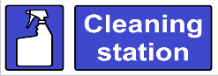  Stationary packs for students who do not bring items arranged  No uniform/ Check on window opening
Fire or other emergencies. | Fire action procedures have been reviewed for the school and Teachers / Assistants are aware of what action to take should a fire break out or the fire alarm is activated. If contractors are on site undertaking emergency work, they will need to be made aware of what to do in case of fire. (For advice and assistance on fire safety please contact health&safety@midlothian.gov.uk)  Staff will make themselves aware of who are the designated first aiders. They will wear suitable face covering / face masks, gloves when attending an incident. Should there be no trained first aiders due to illness, senior staff members will act as 'appointed persons' should there be a first aid emergency. | Fire evacuation procedure established for August.  PPE ordered for first Aiders  First Aid rota –identify available first aiders.
Customers/ Clients / Visitors and deliveries | All non-essential visits will be stopped. Parents / guardians / delivery drivers will be made aware of the temporary arrangements in place for attending meetings, deliveries and collections.  Where practical using ‘Zoom’; Microsoft Team’ or similar will be used for meetings and no face to face contact unless there is a two metre distance between both parties.  Deliveries will be timed to avoid drop off / pick up times, (consider methods to reduce the frequency of deliveries e.g. ordering larger quantities less often).  All deliveries should we be wiping down with sanitising material, unless they will immediately go in to storage and not used for at least 72 hours. | Zoom for Wellbeing and 16+ meetings unless large classroom available to allow distancing with review in October 2020. Parents/students may be in school but professionals will be asked to attend the meeting remotely.  Parental Information Letter to outline guidelines. End June/Early August.
Hazards | Control measures | Examples
Visitor / intruders | Security arrangements will be maintained at all times and no members of public allowed into the building. Only Council officials / PPP Management personnel that show their badge will be allowed entry.  A poster will be displayed on the front door stating that there is no public / contractor access into the building unless prior arrangement had been made and agreed.  All visitors to the school must sign in and leave track and trace details at the start of their visit.
Vulnerable staff | Any employees within vulnerable groups will be offered an individual risk assessment to identify supports required. This will be led by Mr Biddick.  This includes:  - Is a vulnerable person, (by virtue of their age, underlying health condition, clinical condition or are pregnant).  - Is living with someone in self-isolation.  - Is within 14 days of the day when the first member of their household showed symptoms of Coronavirus.  - Has been advised by a notification that, in accordance with that guidance they need to follow rigorously shielding measures.  - Adherence to ‘test, trace, isolate and support’ (TTIS or Test and Protect) practices. | Staff in vulnerable categories should check individual advice with their GP or the medical professional in charge of their care or the care of the person they live with as to up to date and accurate assessment of needs. This should be discussed with C Biddick to allow a risk assessment to be completed. If necessary OHSAS referral to be made to support staff.
Staff travelling to work | Staff should consider the following options:  - Walking is probably the safest method of travel, observing the 2 metre rule at all times and avoid pressing crossing patrol buttons with fingers, where possible (use a pen or similar).  - Using their own bicycle, if they have access to one. The distance to be travelled of course may be too great or too arduous. Where a push bike is used, again the 2 metre rule must be observed when waiting at junctions, etc. and there are other pedestrians or cyclists in the vicinity.  - Using their own car, it is advisable that they sanitise keys, boot and door handles, steering wheel, gear shift, handbrake, radio buttons and instruments used, including seatbelts, cup holders, mobile phone holders. When using fuel pumps, use the disposable gloves provided at the filling station or wipe the pump handle prior to use, with a sanitising wipe. If offering a lift to a friend or colleague, the points below in 4 and 5 should also be followed.  - Where car sharing is required, it is advised that it is only undertaken if:  - There is only one passenger, both wear a face covering and no face to face contact. The passenger should sit in the rear of the vehicle on the opposite side to the driver, and the windows opened.  - They have asked the other person if they are suffering from any COVID-19 symptoms or if anyone in their household has any symptoms.  - No food or drink is consumed during the journey and avoid touching the face during the whole trip and refrain from touching / leaning over towards the other person.  - Where public transport has to be used, wear a face covering and ensure that the social distancing is maintained in line with current guidance. Contactless payment methods are preferable to cash. It is recognised that fellow passengers will be wishing to exercise similar precautions which will assist with social distancing. It is advised that they use their own supply of hand wipes to keep hands as clean as possible and avoid eating or drinking whilst on public transport. | Staff to assess the best option for themselves.  Shower facilities for cyclists will not be available - staff should be aware.
Airborne spread of COVID 19 | Staff and pupils at school must at all times wear face coverings when moving around the school in corridors, office and admin areas, canteens (except when dining) and other confined communal areas, (including staff rooms and toilets) and where ever they cannot keep 2m distance with others.  Please note: canteen/communal areas in PHS are not classed as “confined”.  All staff and senior pupils should wear a face covering in classrooms during lessons.  Classroom assistants should wear face coverings at all times, (except when dining).  Where required transparent / see through face coverings may be used, i.e. to improve communications.  ‘Wear a face covering in this area’ signs will be displayed.  It is noted that some individuals are exempt from wearing face coverings and this will have been agreed with the Head Teacher.
Parents / guardians drop off and collection of pupil | To minimise the risks at drop off and collect points:  - Staggered drop off / pick up times and where practical use additional locations.  - Signage outside the school gates informing parents / carers to wear face coverings.  - Two metre distance markers on the pavement to discouraged gathering outside the school gates.  - Parents / carers provided with details of on arrangements on car drop off / pick up:  - Parking further away and walking children to the school.  - Using active travel routes where feasible.  - Where practicable, do not undertake car sharing with children and young people of other households  Specific arrangements agreed with parents / carers for parents / carers of children and young people with additional support needs or disabilities, who may normally drop their children off within the school building, and those who arrive at school using school transport, including taxis.
Vulnerable staff / pupils | - The published extra protection level 3 advice states:  - Parents / carers of children who have previously shielded or who have a underlying health condition should discuss with their GP or clinician whether they should attend school.  - Staff who have previously shielded or who have an underlying health condition can continue to work in schools, subject to a dynamic risk assessment confirming it is safe to do so.
Extracurricular Small Group Meetings (pupils) | When small groups are meeting (for extracurricular purposes) the following should be adhered to:  - Desks will be cleaned before and after meeting  - Pupils will wash hands as they enter room  - Room will be ventilated throughout with windows and classroom door open  - Masks will be worn throughout meeting  - Different age groups must be socially distanced when meeting in the area  - Seating plans will be in place and uploaded to Google Classroom once finalised  - Pupils will have lunch before meeting so no food items consumed in meeting room  - If any student/staff member displays symptoms, COVID 19 Protocol will be followed | See advice in earlier sections.
Small Group Meetings (pupils with visiting specialists) | When small groups are meeting with visiting adults (for approved purposes) the following should be adhered to:  - The same room should be used for each time the group meets.  - Desks will be cleaned before and after meeting  - Pupils will wash hands as they enter room  - Room will be ventilated throughout with windows and classroom door open  - Masks will be worn throughout meeting  - Different age groups must be socially distanced when meeting in the area  - Seating plans will be in place and uploaded to Google Classroom once finalised  - If any student/staff member displays symptoms, COVID 19 Protocol will be followed  The visiting adult(s) must:  - sign in and leave track and trace details at the start of their visit.  - hand sanitise when entering and leaving building/rooms  - wear a face covering at all times  - following one-way system  - maintain 2m social distaance from other staff and students  - must only visit one school site per day | See advice in earlier sections.
Hub Provision (from January) | Please note; all health and safety measures above should be followed with the additional measures outlined below:  - all pupils and all staff should wear masks at all times (unless medical exemption has been granted). Requirement that staff only wear approved surgical masks  - All pupils and all staff should use sign-in sheet  - Non-hub staff are required to update visiting log timetable before visiting the school  - All pupils should be assigned a hub bubble group and remain 2m distanced from other pupils in hub classrooms
Blended Learning  (15 March to 1 April) | Please note; all health and safety measures above should be followed with the additional measures outlined below:  - all pupils and all staff should wear masks at all times (unless medical exemption has been granted). Requirement that staff only wear approved surgical masks  - all pupils and staff must be 2m socially distanced at all times.  - Pupils will be expected to remain in allocated classrooms for break/lunch. Those in science should report to the Assembly Hall. Pupils should also remain on-site for break and lunch.

Staying COVID-19 Secure in 2020

We confirm we have complied with the government’s guidance on managing the risk of COVID-19

FIVE STEPS TO SAFER WORKING TOGETHER

We have carried out a COVID-19 risk assessment and shared the results with the people who work here

We have cleaning, handwashing and hygiene procedures in line with guidance

We have taken all reasonable steps to help people work from home

We have taken all reasonable steps to maintain a 2m distance in the workplace

Where people cannot be 2m apart, we have done everything practical to manage transmission risk

Employer |  |  | Date
Who to contact:
(or the Health and Safety Executive at www.hse.gov.uk or 0300 003 1647)

